The death penalty has long been a topic of heated debates in the United States. Is it just? How does it not violate the eighth amendment clause of cruel and unusual punishment? Should we abolish it? One of the biggest debates is if the penalty itself is racist. Many believe people of color are executed disproportionately to white people. The focus of this research is to compare the total number of executions of black and white, as well as the current racial makeup of death. This research was updated through October 10, 2023, but there were executions and sentences handed out after the conclusion of this research.

The death penalty is currently federally protected, but the right to administer the death penalty is up to the states. It was briefly suspended by the Supreme Court case *Furman v. Georgia* in 1972 but was reinstated in 1976 under a series of cases referred to as the *Gregg decision.* It is currently legal in 27 states, but three of them (California, Pennsylvania, and Oregon) have placed it under a gubernatorial moratorium. As of December 1, 2023, only five states (Texas, Florida, Missouri, Oklahoma, and Alabama) have executed people and only 7 (Alabama, Arizona, California, Florida, Louisiana, North Carolina, and Texas) have sentenced people to death.

I spoke to former First Chief ADA of Onondaga County and current Syracuse University professor, Rick Trunfio, about his thoughts on people arguing that the death penalty is racist. Professor Trunfio has worked on several death penalty cases and has taken one to trial here in Syracuse. He believes that while there have been cases that have been biased because of the individual’s race, that the entire system is not racist. “For there to be institutional racism, the government has to actually support laws that oppress people based on their race,” Trunfio said. “Those laws don’t exist anymore.” Trunfio does not believe in institutional racism, arguing that many people are painting broad brush strokes and looking at who the defendant is rather than what they did. “I’m not denying that racism exists,” he made clear, “but for someone to believe in institutional racism, they also have to believe that every actor within the judicial system is racist, and that simply is not true.” Trunfio makes it clear that it’s not who committed the crime-but what they did that matters.

Since the reinstation of the death penalty in 1976, 1,578 people have been executed. 878 of those executed were white and 538 were black. If we were to calculate per 10,000 people, three times more black people have been executed than white people. However, because the total number of people executed is very small compared to total populations, it is a broad jump to say the death penalty is racist based on just these numbers. We can also look into the racial makeup of people currently on death row to determine if it is disproportionate or not. This way, we can see how and if it affects each race disproportionately between both executions and current makeup of death row. Below, we can see the comparison of white people vs. black people executed each year.

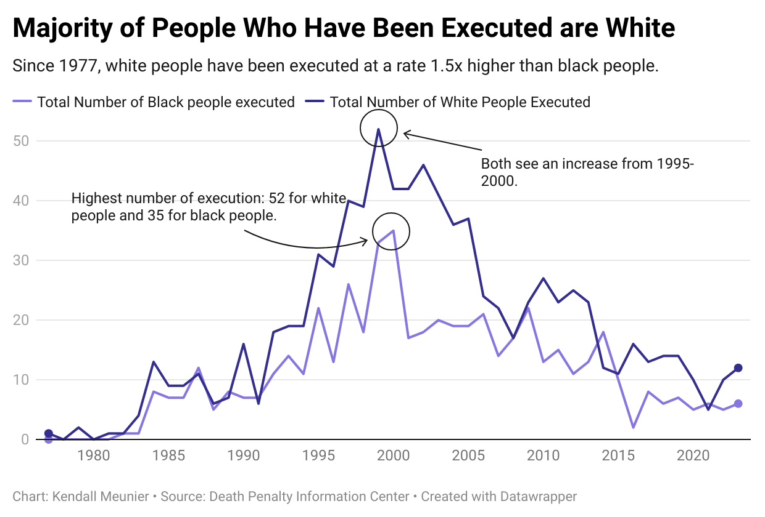

As of January 1, 2023, there are 2,331 prisoners on Death Row. California, despite being under a gubernatorial moratorium, has the greatest number of inmates on Death Row, at 665. According to the Death Penalty Information Center, the current racial makeup of Death Row is as follows: 41% (961) are black, 14% (325) are Latinx, 42% (978) are white, and 3% (67) are identified as “other.” If we were to calculate the ratio per 10,000 people, there would be six times more black people on Death row than white people. While these numbers are still very small, combined with the total number of executions in comparison to their population, they do hint at racial bias. Black people currently represent between 12-13% of the population, but almost half of death row. Their total population is about 20% of the white population. Below we can see the current racial makeup of death row and of the United States population.

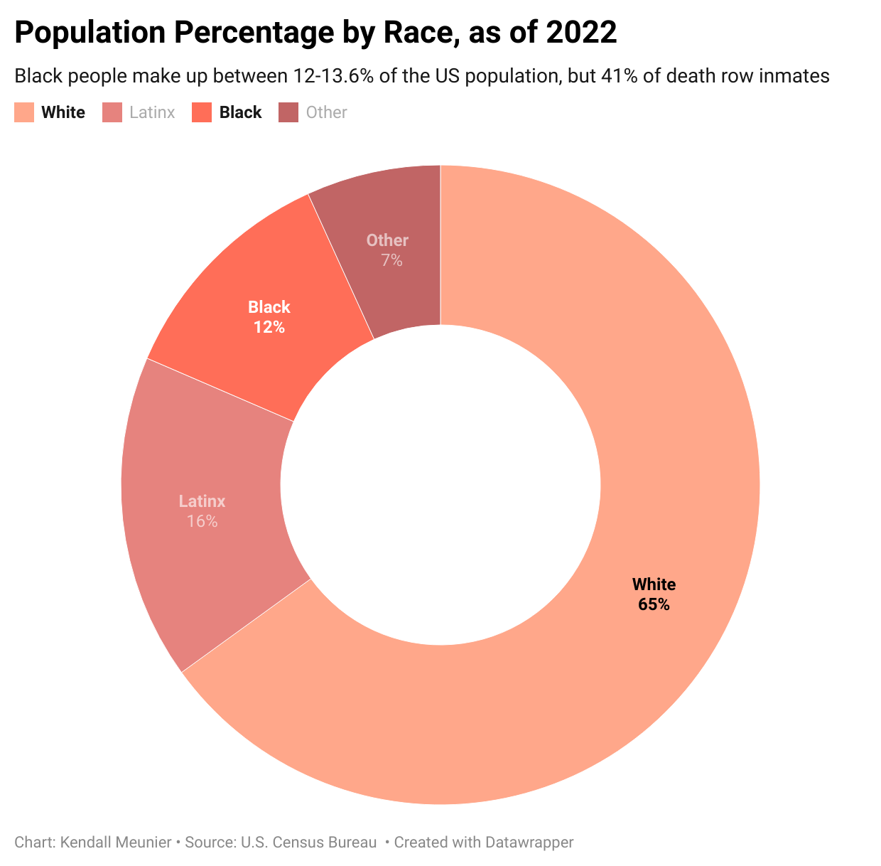

A study conducted by the [Death Penalty Information Center](https://deathpenaltyinfo.org/policy-issues/innocence) found that, “Since 1973, 195 former death-row prisoners have been exonerated of all charges related to the wrongful convictions that had them put on death row.” 106 of those prisoners are black. However, this study does not point out what the cause for each exoneration was. Rick Trunfio discussed this topic in one of his classes, in what he calls legal innocence vs. actual innocence. “Actual innocence means the defendant has been proven factually innocent; legal innocence means the evidence and facts prove the defendant is guilty, however, a legal error, legal issue, or procedural issue provides a basis for an appellate court to reverse the conviction.” This makes it difficult to find the underlying reason for the reversal; were they truly innocent or was a clerical error made?

This is an extremely difficult topic to research and discuss. It is not black and white by any means, and my research is not the final answer. While the numbers do suggest there is racial bias, it is hard to prove institutional bias, as mentioned in my conversation with Professor Trunfio. This is an extremely heavy topic that I believe, no matter how much research is done for both sides, and no matter who has more “proof,” there will never be a solid answer to this question.